1. Order Entry:

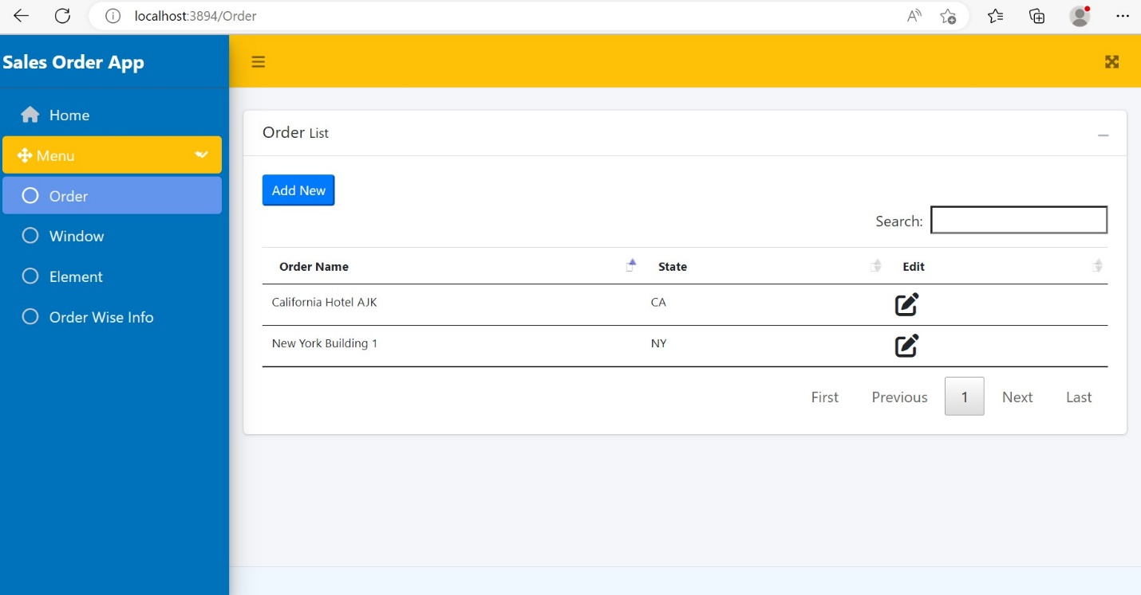

1. Window Entry:

1. Element Entry:

1. Order Detail Info:

Update Order Details:

